Prepaid Energy Meter with Theft Detection

The Prepaid Energy Meter with Theft Detection System mainly works for detecting internal as well as external energy theft.
Internal energy theft occurs after the energy reaches to energy meter while external energy theft occurs before the energy reaches to energy meter.
The system works for theft detection and also allows user to use prepaid energy meter functionality.
Using this functionality user will able to pay in advance and use the exact amount of energy.
The system starts with GSM modem Connection and first configures the user number and gives authority to that number.
When the external or internal theft occurs in system, the system immediately inform authority or user with message also system will able to send message when the prepaid balance is low or Zero.
The system is made up of AVR Microcontroller, current sensors , GSM modem, LCD display ,energy meter and loads.

Block Diagram :
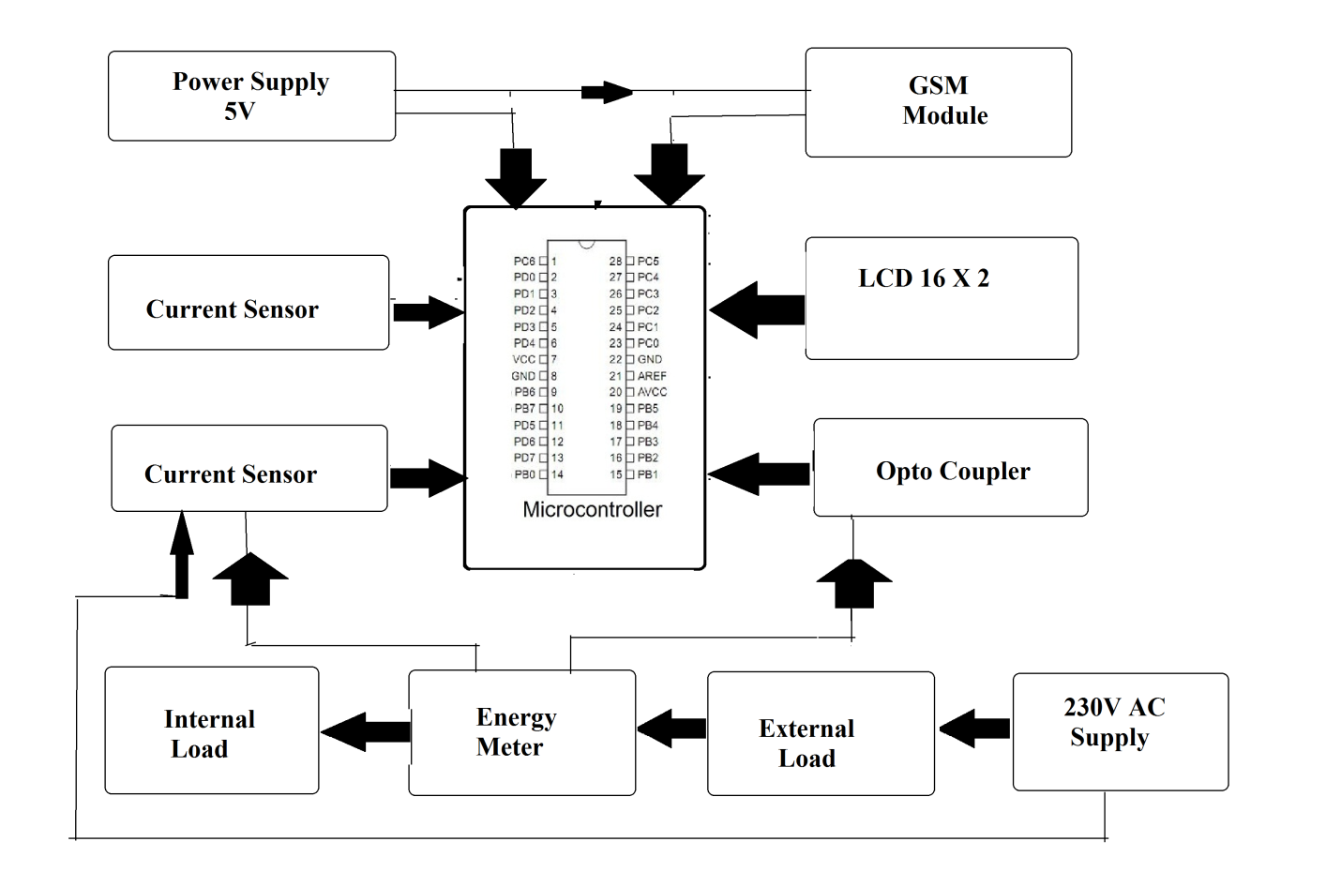
Hardware Specifications :
- Atmega 328 Microcontroller
- Current Sensor
- GSM Modem
- LCD Display
- Energy Meter
- Loads
- Resistors
- Capacitors
- Diodes

Software Specifications
- Arduino Compiler
- MC Programming Language: C

Reference
- http://ieeexplore.ieee.org/xpl/articleDetails.jsp?arnumber=6527721&queryText=prepaid%20meter&newsearch=true

- http://ieeexplore.ieee.org/xpl/articleDetails.jsp?arnumber=7334061&queryText=prepaid%20meter&newsearch=true

